|  |
| --- |
|  |

|  |
| --- |
| C:\Users\Administrator\AppData\Local\Microsoft\Windows\INetCacheContent.Word\asn-logo-de.png |

|  |
| --- |
| **Virtual Buzz:**  **Simulating visual Influences of Alcohol in an Augmented-Reality App** |

**Term Project**

Department of Computer Science

University of Applied Science Rapperswil

|  |
| --- |
| Fall Term 2016 |

Authors: Konrad Höpli, Roberto Cuervo-Alvarez

Advisor: Prof. Oliver Augenstein

Project Partner: Fachstelle Am Steuer Nie (ASN), Zürich

Student Research Project Thesis:

VirtuallyUnderInfluence



Simulating visual Influences of Alcohol in an Augmented-Reality App

Autors:

Konrad Höpli, Roberto Cuervo-Alvarez

Supervisor:

Oliver Augenstein

Industrial Partner:

Fachstelle Am Steuer Nie (ASN)

Hochschule für Technik Rapperswil | HSR

2016

Table of Contents

1 Abstract 4

1.1 Introduction 4

1.2 Approach 4

1.3 Results 4

2 Introduction 5

2.1 Overview 5

2.2 Goals and Objectives 5

2.3 Content Overview? (Mini summary per Chapter) 6

3 Background 7

3.1 Fachstelle Am Steuer Nie (ASN) 7

3.1.1 Motivation 7

3.1.2 Existing Tools 7

3.2 Personal Motives 7

3.2.1 Konrad Höpli 7

3.2.2 Roberto Cuervo-Alvarez 8

4 Different Realities 9

5 Vuforia 11

5.1 Features 11

6 Unity 11

6.1 Basics 12

6.2 Features 13

6.3 Assets 14

6.4 Shaders 14

7 Visual Effects 15

7.1 Information about Alcohol Effects on Vision Capabilities 15

7.1.1 Blurred View 15

7.1.2 Inconstancy 15

7.1.3 Tunnel View 15

7.1.4 Red Light Weakness 15

7.1.5 Duplications 15

7.1.6 Flash/Night Blindness 15

7.2 Image effects in Virtual Buzz 17

7.2.1 Blur 17

7.2.2 Randomization [9] [10] 18

7.2.3 Tilt Shift 18

7.2.4 Color Correction 18

7.2.5 Delay 19

8 Solution/Implementation 21

8.1 Development 21

8.2 21

9 Challenges/Conclusion 22

10 Game Ideas 23

11 Table of Figures 25

12 Images 25

13 References 25

# Abstract

## Introduction

The industrial partner ASN (which roughly translates to "never [drink] behind the wheel”) provides information regarding the influence of alcohol and other drugs on humans. To make adolescents aware of the impact of alcohol on the human brain, they use a variety of tools such as (drunk) driving simulators and glasses, which come with impairments, to provide the visual experience of being drunk.

Due to the desire to appeal to their young target audience, ASN sees a lot of value in using leading edge technologies to communicate their message. In case of this project, the goal was to experiment with Google Cardboards and to investigate their current capabilities with regards to being able to simulate some of the visual disturbances caused by alcohol.

## Approach

As a first step, we decided on using the Vuforia augmented reality SDK for the game engine Unity. This way, we had the option to use the additional features coming with both Unity and the SDK made therefore. Especially the various image effects and filters provided by Unity looked very promising for our intentions.

The second step was developing a first prototype of an AR app, which simply used the ‘blur’ component provided by Unity on the running smartphone camera and thereby proofed the plausibility of the project idea. We then went on to attempt implementing the other visual effects described by ASN. Based on the research nature of this project, the whole development process as well as the information gathered on the topic of both Unity and AR capabilities is supposed to be documented well. In a manner to not just give a good insight on the project itself, but the topic and used tools as well. It is aimed at both potential future contributors to this project as well as developers interested in testing the water of augmented reality with the tools used here.

## Results

This project resulted in a functional app which can be used by the attendees of ASN presentations to simulate the visual experience of being drunk. It serves as a proof of concept for the initially uncertain idea to simulate the visual effects caused by alcohol in AR.

The app also identified the currently still severe limitations of the processing power of smartphones regarding the used technologies.

The documentation serves as introduction to the world of AR and Unity while also giving insight on the project itself, the encountered limitations and possible extensions or future projects this could lead to.

# Introduction

This chapter covers an overview of the project as well as the underlying idea and the goals and objectives contained therein.

## Overview

This project was set out to be primarily for research purposes regarding the available technologies and features regarding the uprising “Google Cardboard”-device since neither of the participating parties had any previous experiences with this new area of development. The company “Am Steuer Nie” (ASN) has provided the basic idea for the project, which is to create a new mobile app replacement for the actual glasses with built-in sight impairments they use for demonstration purposes of the influences of substances like alcohol to the human sight (and driving) and possibly use those in a sort of a game to catch the attention of their target audience. The app is not (yet) planned to be released in any app-stores, since that is not essential to the project even though it could be an option for future versions so they can be used in other companies similar to ASN or simply educational purposes in general.

The documentation of our findings and development experiences regarding the new technologies is also an essential part of this project since it is supposed to provide an inexperienced developer the needed insight into the area of virtual and augmented reality as well as game development with the Unity game engine.

## Goals and Objectives

The goals and objectives of this project initially were very vague and partially had to be determined further over the course of the project as we acquired a greater insight on the available tools and possibilities we had. The basic goal laid out was to simply develop some kind of app to simulate the visual impairments caused by the influence of substances such as alcohol while providing a good documentation for all the gained knowledge over this new area of programming as well as all the technologies that had to be used to achieve that.

|  |  |
| --- | --- |
| Initial Requirements | Fulfillment status |
| Working app for simulating substances |  |
| App for Android-OS |  |
| Usage of “Google Cardboard” |  |
| Developing concrete Game Ideas |  |
| Extensive Documentation |  |

In addition to the basic objectives, we were able to split up to whole project further as we went on and identified the following goals along the way:

|  |  |
| --- | --- |
| Identified Goals and Objectives | Fulfillment status |
| Implementing visual effects (split up further) |  |
| Ability to configure Settings |  |
| Configuration Management |  |
| Understanding used Features & Shaders |  |
| Implementing a custom Shader |  |
| Performance Optimization |  |
| Including virtual Objects |  |
| External Controller |  |
| User Manual |  |

## Content Overview? (Mini summary per Chapter)

# Background

This chapter is intended to give a slight insight into the background of both the students as well as the industrial partner involved in this project.

## Fachstelle Am Steuer Nie (ASN)

The industrial partner Am Steuer Nie, ASN for short, (which roughly translates to: “Never behind the wheel”) is a rather small company with the goal to teach people between the ages of around 14 and 22 about the negative influences of substances like alcohol and drugs on the human capabilities especially regarding driving. The focus regarding substances thereby lies on alcohol and they have a variety of tools at their disposal in order to provide a somewhat realistic and immersive experience.

### Motivation

A part of the motivation to develop a new AR-App simply comes from making use of the newest technologies available and expanding the tools available to continue making the simulation of the big variety of effects, which alcohol and other substances can have on our well-being, more realistic. Along with that aspect also comes the ‘hype-factor’ that these still relatively new kinds of technologies typically have on the younger generations and therefor possibly improves the reception of both marketing and the actual demonstrations.

### Existing Tools

Driving Simulation

Drunkenness Glasses

Documentation and Visualizations

## Personal Motives

This chapter is supposed to give a somewhat detailed insight into why we personally chose this project for our term project without much hesitation.

### Konrad Höpli

Aside from the opportunity to really get into some of the newest technologies on the market, I also have been enthusiastic about gaming and its connection to the real world, which really is what AR tries to tie together on a new level. I think in most games the primary goal is to either create a really immersive and fictional experience (e.g. Life is Strange, Ori and the blind Forest) or being as realistic as possible (e.g. various kinds of simulations and even war-games like Battlefield 1). In the future I strongly believe, that the first kind will move over to virtual reality and the second kind has potential to be continued in augmented reality. However, looking at the current experiences available and the first impression of the limitations still out there, I will definitely hold on to the statement, that this is still futuristically speaking.

The other part of my motivation for this project comes from my personal lifestyle that really values both healthiness and responsibility. The responsibility aspect has basically always been important to me and surely has a relation to how I was raised on the farm of my father. Although I do drink some alcohol from time to time and consider a good, cold beer one of the best drinks available, I am heavily against all kinds of excessive substance consumptions with a negative impact on our ability to, well, function. Especially if it also potentially effects not just ourselves but other living beings.

I am also very grateful for being able to take on this project together with my good friend Roberto and our advisor, Prof. Augenstein. I have had the pleasure of getting to know Roberto really well over the last couple of years and projects. During these I have not only learned from his vast experience, but also found out, that we tend to complement each other rather well. My experiences with Prof. Augenstein during most of my math courses have also been very pleasant and influenced my motivation. Even though mathematics is not one of my strong suits, his ability to explain complex algorithms in a simple (or IT related) manner have resonated well with me.

### Roberto Cuervo-Alvarez

I can divide the roots of my motivation for this project in three big categories:

**Technological reasons**

These are obvious: the possibility of testing the waters of the world of virtual and augmented reality and learning its technologies could not be more interesting. Although we have seen that these technologies are not yet fully developed and product-ready during this project, the simple act of working “on the cutting-edge” of technology was very exciting.

**Philanthropic reasons**

I am not a drinker and I personally suffered a loss in my youth exactly because of the relationship between alcohol and cars. So, it was really appealing to me to seize the opportunity of trying to help ASN in the battle against alcohol behind the wheel. Even the smallest effort counts and if one young person remembers his/her experience with our app in a given moment and then decides not to drive while being drunk, this would be more than enough for me.

**Personal reasons**

My personal reasons are obvious for me too. The opportunity of working with my classmate and friend Konrad could not be better. During the weeks we worked together, I think we have become a good team and in spite of unexpected diseases, I think we made a good job. I also cannot forget Prof. Augenstein. I have known him before attending this school and visited some of his math lessons and profited greatly from his knowledge, patience and support.

# Different Realities [1]

One of the goals of this project is the development of an app that should be used to visualize the negative visual effects that substances just like alcohol can have and this is best done by creating an experience as immersive as possible. One of the current trends regarding immersion is the usage of augmented and virtual realities with the help of some of the newest tools available such as Google Cardboard, Gear VR and the HTC Vive or Oculus Rift. The first ones depend on the processing power of modern smartphones whereas the latter ones rely on computer hardware optimized therefore. All of devices remain rather uncommon, but their popularity surely is rising [2].

The following graphic provides a quick overview about the relationship of the available options using a simplified version of the reality-virtuality continuum described in published papers as early as 1994. While those terms may already have been introduced at that time, the impact and availability of these technologies has only been surging during the latest years.

AR

Figure 1: Simplified Reality-Virtuality Continuum

On the left side of the relationship, there is what we consider the real world as itself (or seen through a display) including existing objects and visuals, but also the constraining laws of physics that apply to them etc. On the right side is the virtual reality, which stands for a completely synthetic manifestation of a world, where its creator is in full charge of the objects existent therein as well as the governing laws they are bound to (or not).

In between the two extrema of this continuum, there is a whole range of possible implementations originally defined as mixed reality (MR), but nowadays mostly referred to as augmented reality (AR) as it is the most common. Depending on where exactly on this relationship an application or game intends to be, it will typically find itself somewhere in between with a focus on either the real world or the virtual reality. In the paper used as a source for this chapter, the points closer to the real world are defined as augmented reality whereas the points closer to the virtual reality are called augmented virtuality. The latter has still not established itself as a common term or application, but may still be to come using the newest technologies we now have at our disposal. A good example for the latter would be a completely constructed, virtual reality where a couple of real objects are integrated into and may even be interacted with.

A key factor about this formulation is, that the point on the continuum is defined by the extent to which the human perception is being altered instead of the mechanism through which the modification is achieved.

In our project’s case, we will try to primarily integrate the real environment using smartphone cameras as an optical see-through-device and image altering technologies to modify the real-world-experience captured and generate a simulation of drunkenness. As such, this project fits perfectly into the original definition of AR since we stay relatively close to the left side of the continuum.

# Vuforia

Vuforia is a software development kit (SDK) aimed at making AR development more accessible and it provides individual versions for Android, XCode (iOS) as well as Unity.

In the beginning stages of this project we had to choose one of the versions provided and since the one for Unity comes with additional features and even though we have no previous experience with the popular game engine we quickly decided to go for that one and use the opportunity to further expand our developer horizon.

During the development of our project a new partnership between Unity Technologies and PTC Inc. was announced [1] with the goal to make AR-development more accessible by integrating the Vuforia toolset into the Unity IDE. Needless to say, this also makes it very likely that the already convenient toolset provided will continue to be improved and expanded in the future.

## Features

# Unity

Unity is one of the most popular cross platform game development tools, also referred to as game engine, used to create video games. It consists of an IDE as well as a visual editor which can be extended by the use of plugins and components, mostly referred to as assets.

Unity itself has a quite low learning curve to get started, which is most likely one of the reasons why it became so popular recently. Other reasons are it being very well documented and free, which makes it very user friendly and attractive for users without prior programming knowledge. Besides its good documentation, it has a strong community behind it which allows new users to access the Unity forums to solve their programming issues with the assistance of more experienced programmers, or to discuss solutions and share acquired knowledge.

## Basics

As already indicated, Unity is more than a simple tool and comes in separate parts, which individually contribute to both the toolset available as well as the overall user experience. It is one of the most popular game-engines available today and thanks to its licensing model especially popular among indie- as well as hobby developers. The following graph puts into perspective, how many of the most popular free mobile games in the first quarter of 2016 have been made with the game engines available:

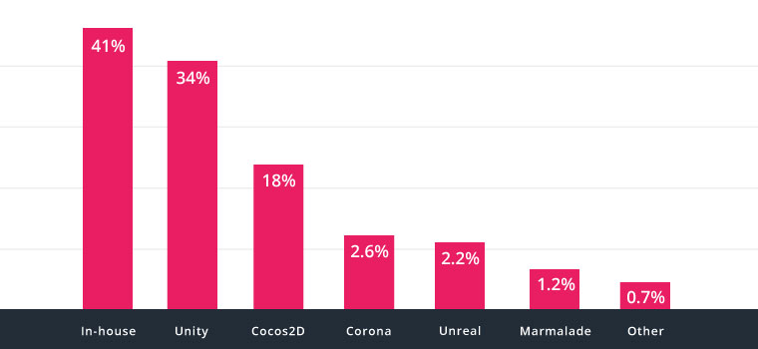

Abbildung 1: top 1000 free mobile games by engine [2]

While this graphic provides a decent idea of the popularity of Unity especially among free games, it does not show what the engine is actually capable of. Iin order to get a better idea of that, it is recommended to have a look at the platform [3] available to promote games made with Unity.

**Game Engine**

The game engine is what makes sure the created games can be run on a specific platform or environment, and in the case of Unity this is possible for basically all popular gaming-platforms such as PC, Android, Xbox as well as PlayStation.

**Integrated Development Environment (IDE)**

The IDE provided and developed by Unity Technologies really embraces a convenient concept that is not just for professional developers, but also easily understandable for users without a programming background even though games are generally seen as one of the most complex technical challenges available.

One of the primary reasons it does not require a development background is the separation of concerns used by Unity. The IDE itself is not intended to write a single line of code, but uses a very component based approach set in hierarchical scenes and customized using the configurable properties in the inspector window. The components are also referred to as “assets” and are one of the aspects, where the unity-developer-community really shines thanks to the integrated asset store, where anyone can share their developed assets (e.g. images, 3D models, animations, sounds and toolkits like the Vuforia SDK) with others at a price or completely for free. The amount of user collaborations is really impressive, but depending on the search term you may also struggle with finding what you are looking for since the description as well as the actual quality is of course very individual.

These components are one of the core concepts used by Unity and are really great for (but not limited to) making games due to the possibility to make each individual model used reusable as well as extendable. So, in case your game contains two humans, you are free to choose between two completely individual models, or the usage of a so called “prefab”, where you assign specific properties upon each instantiation, and can add components such as behaviors to both of them as you desire. This can lead to cases where using a simple cube as an obstacle is as simple as using a car- or plane-model for the same purpose.

**Code Editor**

The Coding IDE that comes with Unity is called MonoDevelop and provides a rather simple, straightforward experience. It is listed as a separate part of the IDE here, since it is rather loosely coupled to the Unity IDE in that it only opens when the user wants to edit a script component and developers are actually free to choose any other coding environment such as VisualStudio.

Unity allows scripting in C# (Version 4.0), Unity Script (JavaScript for Unity) as well as Boo. Due to the low usage of Boo, the scripting manuals and documentation are as of the version 5 of Unity only focused on the other languages available.

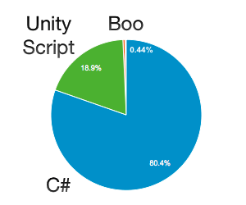

Abbildung 2: Distribution of Scripts created by language [4]

The individual scripts you may or may not implement throughout the development of your project will then simply be used just like any other component with a few minor tweaks. For example, any public properties in your C# script as well as the ones manually marked with the attribute “FieldSerializable” will show up in the properties window and be configurable. Individual methods defined with your script can also be assigned to the respective events such as a button-click and will then be delegated once triggered.

Our project has primarily been focused on C# scripting as well as the usage of a couple of the provided image filters and shaders (which are typically made in C Graphics or Cg in short).

## Features

Game Preview & Runtime changes

Profiler

Debugging

## Assets

Assets, which are mostly community built, are ranging from simple textures and models to complex editor extensions as well as scripts. These can be acquired from the asset store on the web or within the engine or created yourself.

## Shaders

A shader is a pre-compiled program for one of the number of stages of the graphics pipeline used in three-dimensional graphics to determine the final parameters of the object or image. It may include a description of arbitrary complexity absorption and scattering of light, texture mapping, reflection and refraction, shading, surface displacement, and postprocessing effects.

Programmable shaders are flexible and effective. Seemingly complex surfaces can be visualized with simple geometric forms. For example, the shaders can be used to draw a three-dimensional surface of the ceramic tiles on a completely flat surface. In Unity, shaders are divided into three types: vertex , geometry , and fragment (pixel).

# Visual Effects

A crucial goal of this project is the implementation of a realistic simulation of what it means to be drunk or under the influence of other drugs using the technological toolset available at the time. Due to the focus on the experience and cooperation, we relied on the information provided by our industrial partner and did not go into scientific detail.

Many effects of alcohol and other substances such as balance issues, delayed reaction times and motor functions of course are important too, but these are not the focus of this project. Some of them may also be experienced when simply wearing a VR headset. This heavily depends on the individual as well as the duration during which it is worn though and is by no means calculatable.

## Information about Alcohol Effects on Vision Capabilities

Our industrial Partner ASN has provided us with information on the most essential visual effects of alcohol as well as other drug related substances. This information served this project as a basic element as we tried to implement as many of those effects as possible while also trying to keep the simulation as realistic as possible. The effects listed below are ordered based on the priorities we have assigned them in cooperation with ASN.

### Blurred View

**Similar to the increase in reaction times, it takes longer to capture and focus the surroundings while intoxicated. This can result in a blurry vision especially when the eye is not trying to actively focus on a particular object.**

### Inconstancy

All of the impairments mentioned in this chapter are not behaving in a predictable manner or always at the same ‘values’, but may change over time. It also is a possibility, that everything seems fine and clear as long as one remains sitting still. As soon as movement gets involved and the number of things to process drastically increases though, the substance related influences may start to manifest.

### Tunnel View

The human field of vision encloses usually 180 degrees. Sadly, you can only see sharp in a much smaller field of view (around 50 degrees) than that. Regardless of that, the peripherical vision is very important because it helps you react to warning colors or unexpected movements. Under alcohol influence these 180 degrees reduce steadily, being of course especially dangerous in overtake actions, spotting pedestrians, etc.

### Red Light Weakness

The ability to differentiate between different shades of red is very limited while drunk. This is especially dangerous regarding traffic signals and rear/break lights.

### Duplications

The human eyes both take individual images, which are then used to calculate the actual 3D image received. Under the influences of substances, this calculation can be off and result in certain items appearing to exist multiple times right next to each other.

### Flash/Night Blindness

Human pupils change their size based on the lighting circumstances. The time needed by the pupils adapt to changes thereof is typically longer under alcoholic influence and can lead to a sort of blindness for up to multiple seconds. This is period in time that easily can lead to a crash while driving.

## Image effects in Virtual Buzz

This chapter contains an explanation of the actual effects used within the app. Although the chapter naming is adjusted to match the individual components in our Unity project, the order in which they are explained matches the one used in the previous chapter (see 7.1).

### Blur

The blurriness of the overall image provided by the camera in the app was mainly achieved through the usage of two effects:

**Blur (optimized)** [5][6]**:**

This component implements a form of the “Gaussian smoothing” or “Gaussian blur” effect. This effect is rather common in image processing and primarily used to reduce the detail or noise of an image. This is achieved by selecting small groups of pixels in an image and then filtering out or smoothing the individual pixels with high contrast to the identified center to make the group as a whole appear more alike or unified. As mentioned, this can help with noise reduction so if e.g. an image had a few pixel errors (completely white) distributed over the image and this process was applied, the color of those pixels (but also others) would be changed to something more similar to their surroundings.

The overall reduction of detail within an image while still appearing somewhat close to the original is what we use this component for in our app. the option to change the following values:

* Downsample

This could be used to heavily reduce the image quality before applying the actual effect with the goal to be more efficient while losing more detail. We decided not to use this feature, since the image captured by the camera should still closely resemble the real world as well as possible and is not of exceptional quality to begin with.

* Blur Area

This parameter refers to the size of the pixel groups used in the smoothing process This value was the focus in our app, since it results in the most simple and efficient way to produce the desired blur effect. The user has the option to change the used value himself within the configuration.

* Blur Iterations

The amount of iterations defines the number of passes through the actual blur process. In an effort to optimize the performance and since the adjustment of the blur area already resulted in a sufficient result, we left this value at one iteration.

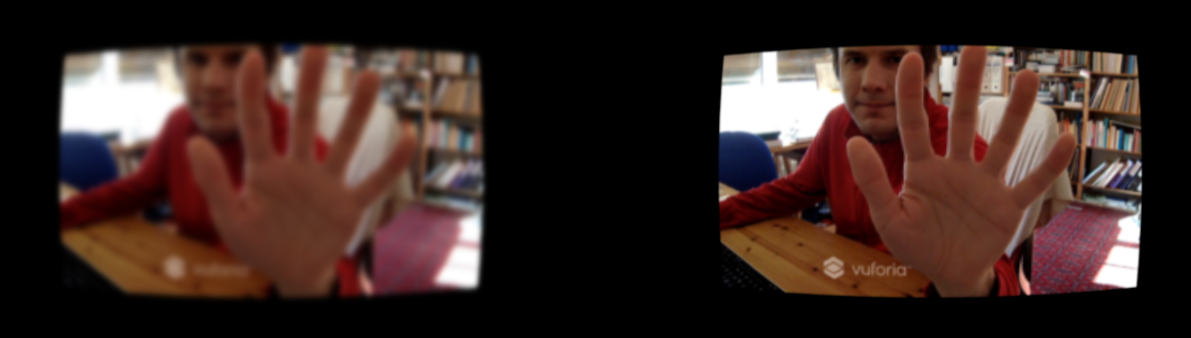

Abbildung 3: Blur Effect Preview

**Camera Motion Blur** [7][8]**:**

As the name indicates, this component is applying a form blurriness based on the direction as well as the speed at which the camera is moving around. It is achieved by calculating a trail for individual pixels from the previously displayed images visualized in a directional blur. The goal is to provide a smoother effect for swift movements instead of the single frames well suited for games with a first-person perspective.

In our app, this effect merely acts as a supplement to the default blur effect as well as the possible side effects from using a smartphone camera. We stuck with the default values provided for all aspects except for the velocity scale. That parameter influences the velocity that has to be reached before triggering the motion blur effect and to which extent it is applied. So, since we are in an AR environment and controlling the camera with our head, we cannot expect movements comparable to the ones with a mouse controlled and increased that value.

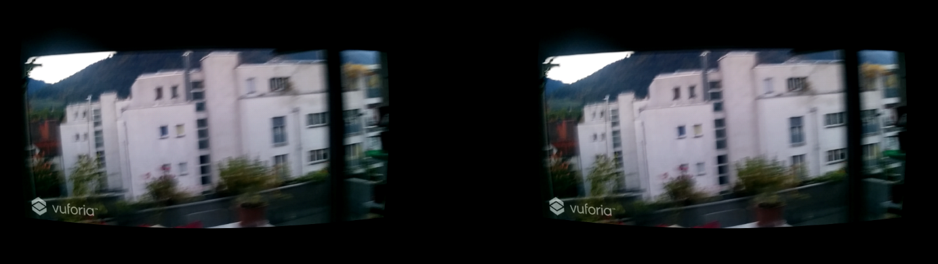

Abbildung 4: Motion Blur Preview

### Randomization [9] [10]

This component was entirely built to provide the experience described in the inconstancy of individual effects while under the influence of substances. It currently applies to the blur and tiltshift components, since those are where the action happens primarily.

The algorithm used for this is called random walk and partially based on the Brownian motion for particles. It essentially performs changes in small steps based on a function rather than assigning a completely new random value to the component. In our case, the probability for each step to remain on the same value is defined as 30%. The remaining probability of 70% is then distributed among the chances of increasing and decreasing while taking into account how close to a boundary the value is. So, directly after initializing the random walk, the distribution is 50/50 leaving the chance to increase the value at the same chance of decreasing (35%). As the current value gets close to one of the boundaries of the possible range, the chance to get even closer to the boundary gets smaller and reaches 0% if the value is equal to it. With the current configuration, the changes potentially happening on each step are barely noticeable, but there is a very noticeable difference between the lower and upper end of the possible range.

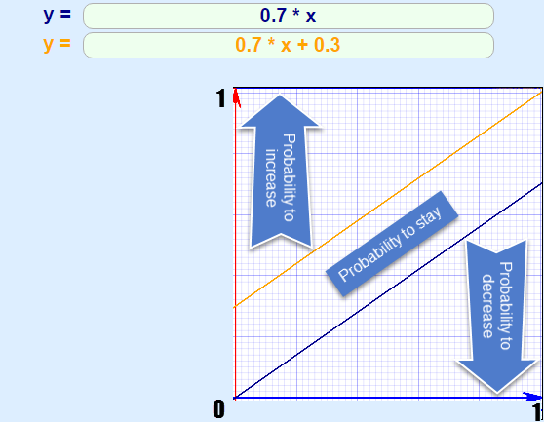

Abbildung 5: Graphical Visualization of the used Random Walk

### Tilt Shift

By wearing a headset such as Google Cardboard and solely looking through the camera of your smartphone already acts as a form of tunnel view compared to our usual vision. This component is used to create a form of an additional tunnel vision by blurring out the parts of the image based on their distance to the center. This is meant to closely resemble that limited ability to focus while under the influence of substances.

The tilt shift component in Unity comes with the following options for configuration:

* Mode

This setting defines whether the distance to the center of an image used for blurriness should be measured vertically or radially. So, the concrete options available are called “vertical defocus” and “radial defocus” and their calculated blur areas can be seen in the following picture: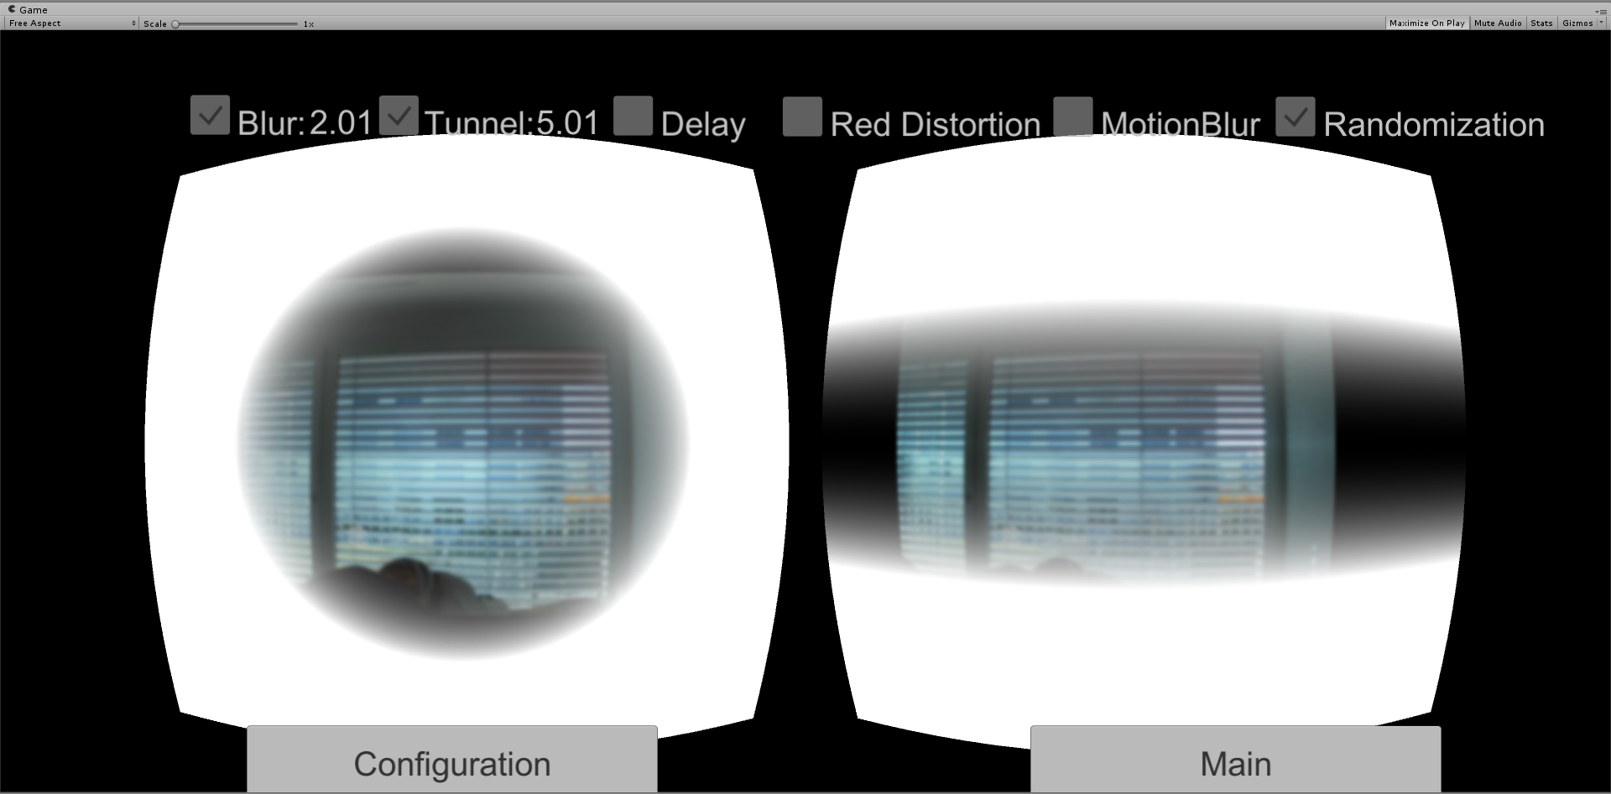

Abbildung 6: TiltShift Modes preview

We considered both of these modes viable, but ended up using the vertical defocus, since the effect is only supplementing the already limited field of view within the AR app.

* Quality

This is referring to the number of samples taken to calculate the individual blur effects. Because this would affect performance when using high instead of normal quality and we use the effect in combination with a regular blur anyways, we went with normal.

The third option is simply made for preview and renders only the blurred areas as displayed in the image above.

* Max Blur Size

The maximum blur distance is defined by this setting and we simply used the maximum of the available values in our configuration.

* Blur Area

This refers to both size and strength of the blur applied in the designated areas. Aside from the regular blur effect, this was the second point of focus in our app and this value is therefore exposed to the user in the configuration of the app.

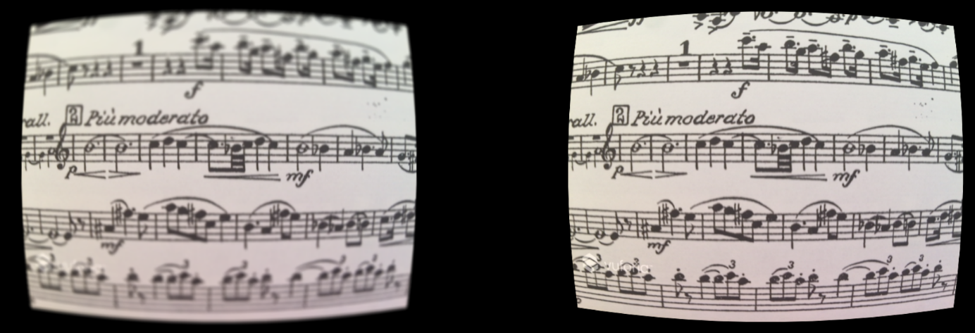

Abbildung 7: TiltShift Preview

### Color Correction

This Image effect tries to simulate the weakness of differentiating between the different shades of red. In order to obtain this visual effect, we use the Color Correction Curves[1] feature from the Unity Image effects.

Color Correction Curves make color adjustments using curves for each color channel (RBG). Depth based adjustments allow you to vary the color adjustment according to a pixel’s distance from the camera.

Curves work on each of the red, green and blue color channels separately and are based around the idea of mapping each input brightness level (i.e., the original brightness value of a pixel) to an output level of your choice.

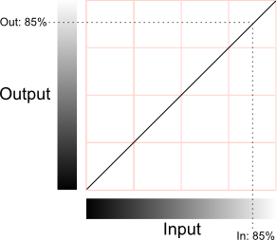

Abbildung 8: Mapping Options of Brightness for each Channel [11]

The horizontal axis represents the input level and the vertical represents the output level. Any point on the line specifies the output value that a given input is mapped to during processing.

In our case, we choose to edit the red channel curve and configured its output in a way that the visibility of the red color is reduced and looks more like black. As you can see in the image below, it is difficult to recognize whether a traffic light is actually illuminated (the light in the image is a bike brake light).

The collateral effect of this curve is the reinforcement of the green color, but ASN told us that this “green effect” complements well the red light weakness because this weakness is stronger during the night. And the green effect slightly darkens the whole vision, so this small side effect is considered acceptable.

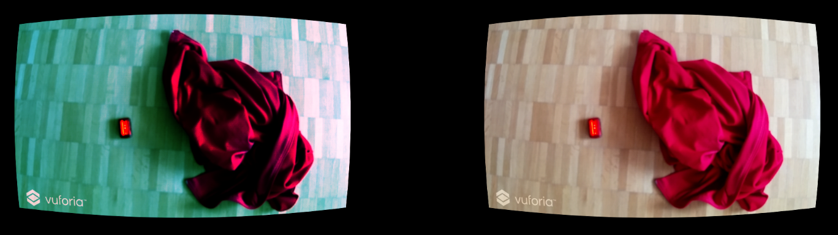

Abbildung 9: Preview of the used Red Color Distortion

### Delay

Depending on the smartphone used, merely using the running camera to look around already comes with a noticeable or even significant delay. This component was created by us to provide an additional delay and to partially acts as a proof of concept for our understanding of image effects in Unity.

This component is called after all the rendering and other image effects have completed. It contains a collection of frames, to which the current image is always added when it is called and enabled. Once that collection reaches a specified limit (in our case 15), the first texture of the collection is displayed on the running camera instead of the current texture. The specified limit was chosen by testing the feature on the smartphone used for this project (Nexus 5X) and creating a delay slightly bigger than a second.

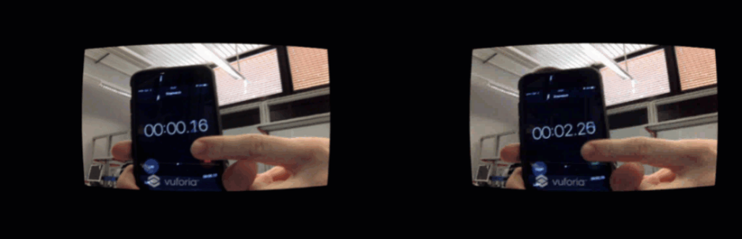

Abbildung 10: Delay Effect Preview

# Solution/Implementation

The goal of this chapter is to provide a better insight into the development and structure of the Virtual Buzz app.

## General Information

All the documents and projects developed over the course of this project are publicly hosted on GitHub under the following Link[2]

|  |  |
| --- | --- |
| **Project Name** | **Purpose** |
| Hsr-semester-arbeit-doc | All documents and files related to the documentation of this project. |
| SimulatingSubstancesApp | The project of the developed app eventually named Virtual Buzz. |
| Hsr-semester-arbeit2016.github.io | An informal development blog written during the development to keep track of our progress and thoughts.  The actual blog can be viewed on this address[3]. |
| VrObjects | An experimental app using a combination of our first attempt at the Virtual Buzz app and some virtual objects as well as the Vuforia ImageTarget feature. |
| VisualEffectSelector | An experimental app, which was our first attempt at using multiple image effects at the same time and allowing them to be configured. |
| TiltShiftArApp | An experimental app, which was our first attempt at using the Vuforia ARCamera and the Unity TiltShift image effect. |

Tabelle 1: GitHub Project Overview

## Development Environment

Within this chapter, we provide information on the software and tools used throughout our development process.

**Unity Project(s):**

|  |  |
| --- | --- |
| **Software** | **Version** |
| Unity Engine | 5.50f3 Personal |
| Vuforia SDK for Unity | 6.1.17 Developer |
| Android SDK | 24.4.1 |
| Microsoft Visual Studio Enterprise 2015 | 14.0.25431.01 Update 3 |
| GitKraken | 1.9.3 Pro |

Tabelle 2: Unity Development Environment

**Project Blog:**

|  |  |
| --- | --- |
| **Software** | **Version** |
| Jekyll | 3.3 |
| GitHub Pages | - |

Tabelle 3: Blog Development Environment

## Code Project (C#)

This chapter attempts to provide a good look into what the C# project of the Virtual Buzz app consists of. This is primarily achieved by using the CodeMaps generated with VisualStudio and a small description on the idea behind the created namespaces. The following image contains all of the custom C# content including the legend for the symbols used therein:

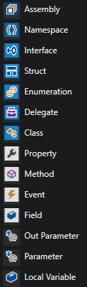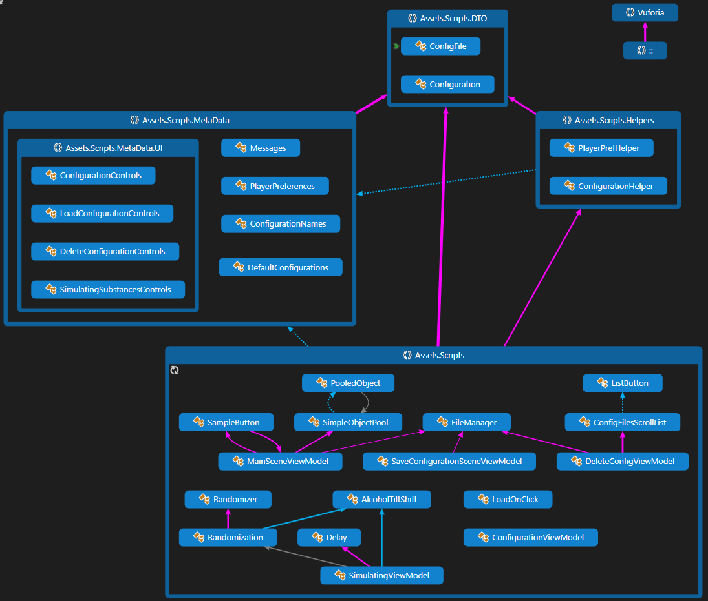

Abbildung 11: Code Map Overview

The more detailed part of the code documentation can be found within the code itself using the XML-comments available in C# just like this:

/// <summary>

/// A component used to perform a randomwalk on a provided value within a range.

/// </summary>

/// <param name="initialLevel">The initial value on which the RandomWalk shall be performed.</param>

/// <param name="totalMin">The absolute minimum that may be reached (usually given by the underlying component of the initial value).</param>

Aside from the ability to read this information provided by scanning through the classes, this kind of comment can also help the user use the components by providing the information while coding in a suitable IDE such as VisualStudio:

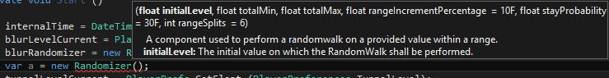

Abbildung 12: VisualStudio XML-Comment Preview

### Scripts

This folder contains all the custom scripts built for and used by our app and thus most of the functionality. All classes with the suffix “ViewModel” are primarily interacting with the GUI-elements of the scenes within the app. Due to the various kinds of classes and their different complexities, there is no further general information provided here, but code as well as the comments within will offer a more detailed insight.

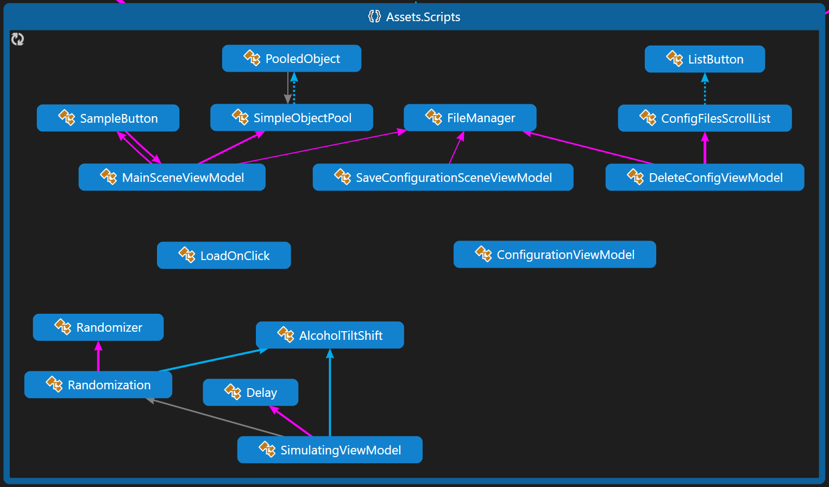

Abbildung 13: CodeMap Scripts

### DTO

This namespace consists solely of the two data transfer objects used for configurations in multiple parts of the app. The only difference between the two serializable classes is the approach to the values contained within – once as a file and once as a concrete class.

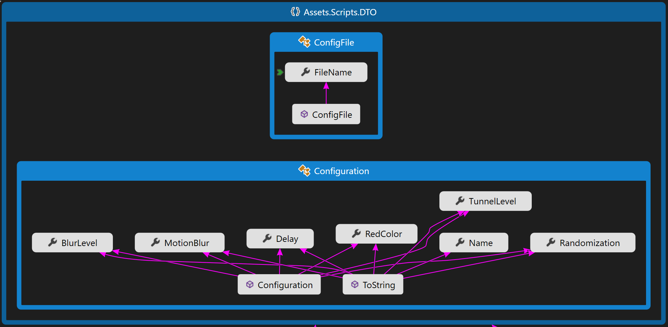

Abbildung 14: CodeMap DTO

### Helper-Classes

The classes within this folder provide publicly accessible classes used to help with common calls to provide configurations and work with the values saved in the player preferences of the app.

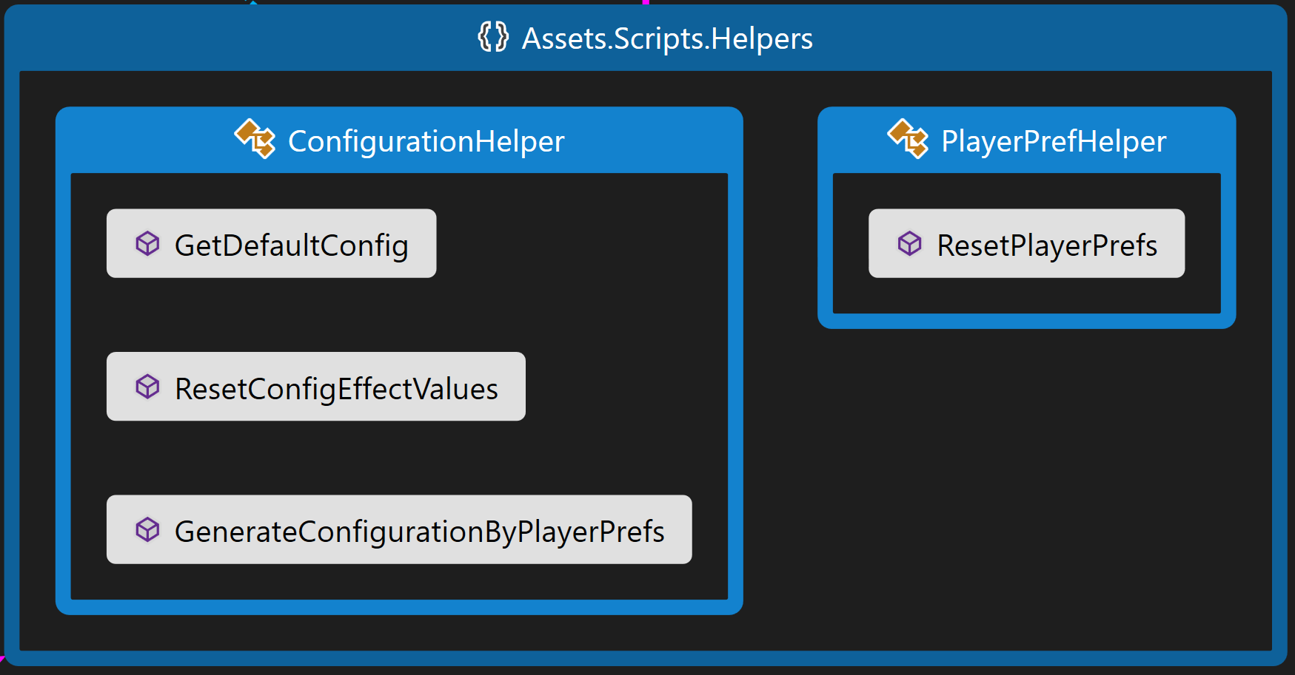

Abbildung 15: CodeMap Helpers

### Metadata

All components within this folder are purely providing information and no functionality at all. One of the primary goals of this is the removal of magic numbers and strings within the code. This also helps with efficiency as well as the avoidance of typing errors due to autocompletion.

This unified access of any kind of static values also provides an easy entry point for future additions to any of the components such as the default configurations.

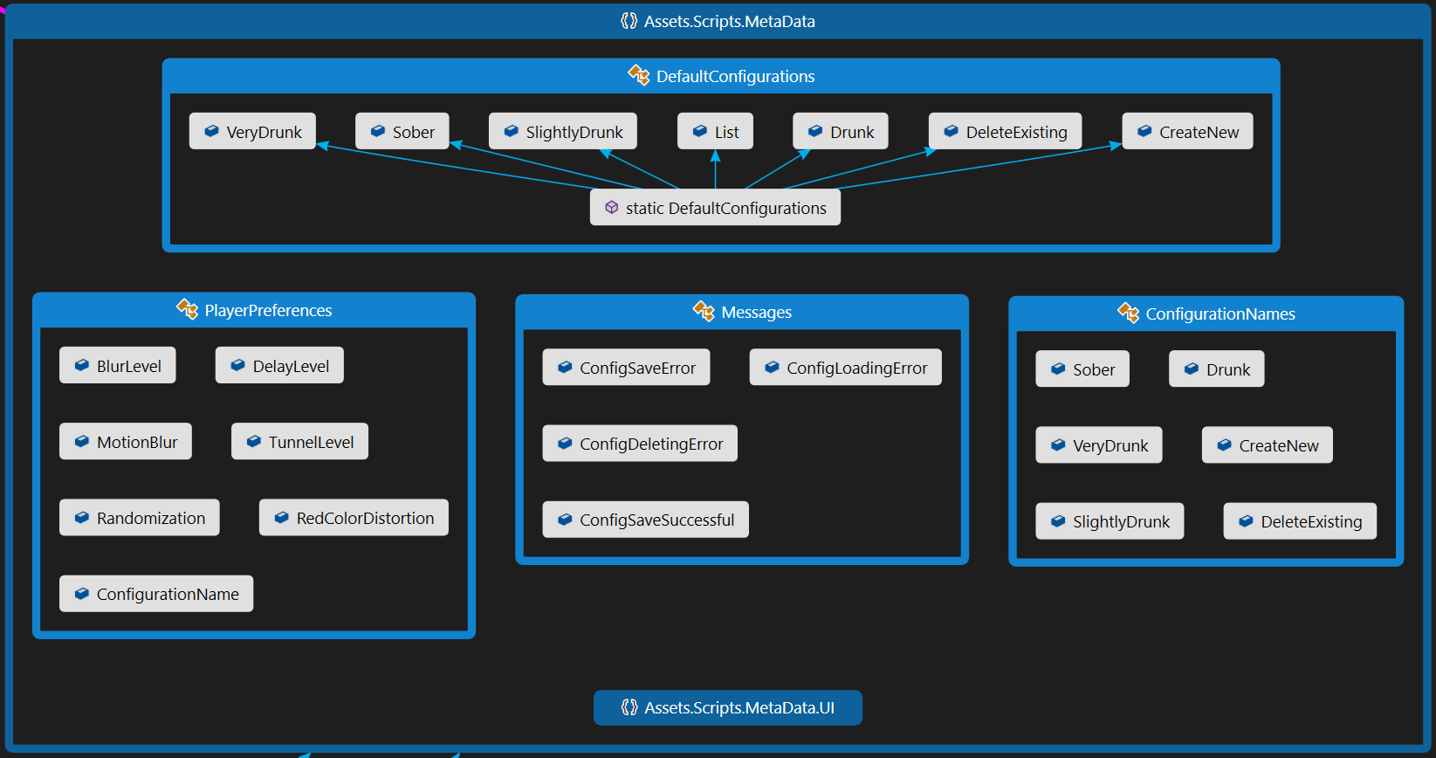

Abbildung 16: CodeMap Metadata

### Metadata.UI

Since all UI components must be accessed via their name in Unity, the same principles used in the metadata namespace also apply here. The classes contained herein all relate to the individual scenes present in the Unity project and cover all the controls used within our custom code.

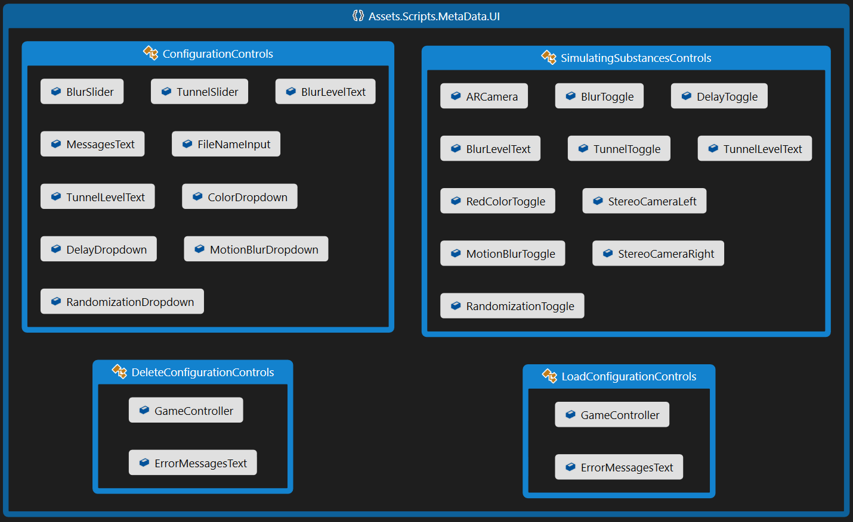

Abbildung 17: CodeMap Metadata.UI

## Unity Project and the Graphical User Interface (GUI)

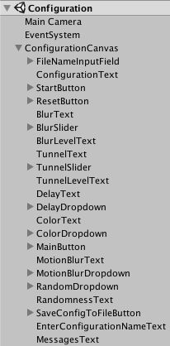Unity uses the term „Scene“ in order to refer to a file, which contains the objects of your game. Scenes can be used to create a main menu, individual levels, and anything else. Think of each unique Scene file as a unique level. In each Scene, you will place your environments, obstacles, and decorations, essentially designing and building your game in pieces.

Abbildung 18: Configuration Scene Hierarchy

The Hierarchy Window in Unity is a hierarchical text representation of every object in the scene. The hierarchy reveals the structure of how objects are attached to one another and can became very complex.

Below we explain the four Simulating Substances application scenes ordered by growing complexity. Each scene has a corresponding C# script responsible of its control following the model-view-controller(MVC) pattern.

For a better understanding of the GUI it’s necessary to explain before how is data preserved between scenes.

### Communication between scenes

A scene is an independent entity with its own lifecycle. That means, that when a new scene is loaded (f. e. a new level in a game) all objects from the previous scene are destroyed.

In order to preserve data Unity provides the PlayerPrefs class, which stores and accesses player preferences between game sessions. This class uses a simple Key/Value system to save the data to a file:

PlayerPrefs.SetInt("Player Score", 10);

var score = PlayerPref.GetInt("Player Score")

We employ this class to preserve the configuration values of the image effects selected by the user so the user can switch between scenes or even shut down the application without losing the configuration.

### Simulating Substances scene

This is the scene where all the action happens. The Vuforia plugin provides the AR functionality with the ARCamera component and the different image effects provided by Unity create the desired effects such as blur or tunnel view.

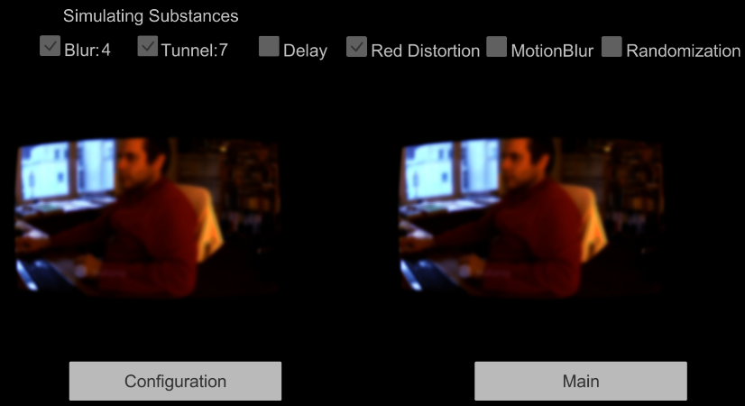

Abbildung 19: Simulating Substances Scene Preview

The effect values shown in the upper part are loaded from the PlayerPrefs when the scene starts. In the **SimulatingViewModel** class:

  UpdateBlurValue(PlayerPrefs.GetFloat(PlayerPreferences.BlurLevel));  
 UpdateTunnelValue(PlayerPrefs.GetFloat(PlayerPreferences.TunnelLevel));  
 UpdateDelay(PlayerPrefs.GetInt(PlayerPreferences.DelayLevel));

        private void UpdateBlurValue(float value)  
        {  
            if (value > 0)  
            {  
                blurValueText.text = value.ToString(); //Shows the 4 in the image

                blurToggle.isOn = true; //Shows the toggle as selected  
            }  
        }

As you can see in the image, this scene contains the application’s main functionality; it shows the user the augmented reality.

**Problems:**

The main problem we discovered in this scene is the size of the augmented reality windows. The following two images provide a comparison of a virtual reality application (top) and the augmented reality application (bottom):

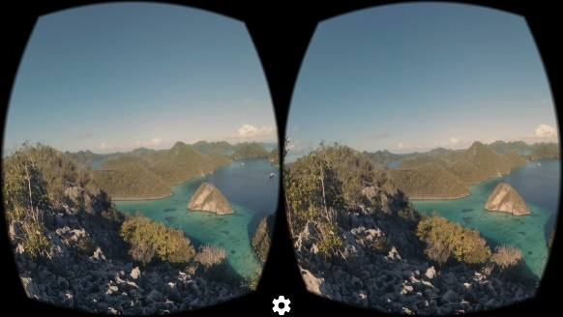

Abbildung 20: Virtual Reality Camera

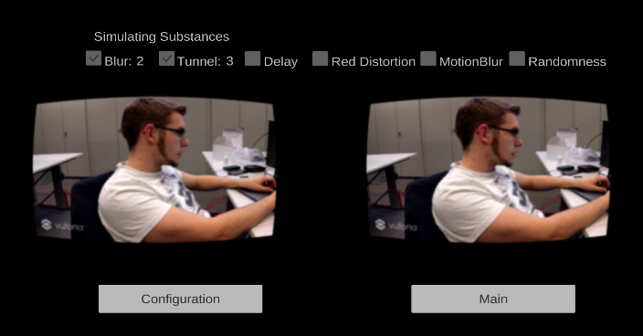

Abbildung 21: Augmented Reality Camera

Although the images are not of the same size, you can see that the size of the augmented reality windows is much smaller. After a rather intense research, we could determine that this is a limitation of the Vuforia Plugin used for augmented reality.

The Vuforia AR Camera only has a 40 degrees Field of View capacity and this condition of course modifies the windows size. The reason for this of course is also related to the image captured by the smartphone camera used by this component whereas in a VR app, the developer can choose to provide a better field of view.

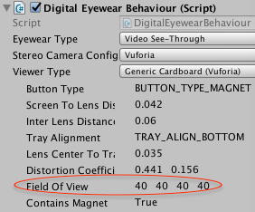

Abbildung 22: Vuforia AR Component Properties

### Configuration scene

In this scene, you can activate or deactivate effects and configure the effects strength. The configuration is saved automatically to the PlayerPrefs. It is also possible to save a custom configuration to a file.

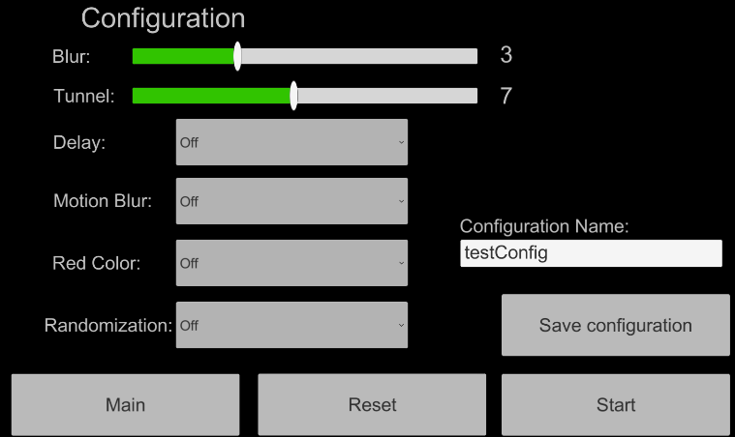

Abbildung 23: Configuration Scene Preview

**Problems:**

The Configuration scene has more GUI components and this increases automatically the logic complexity. The Dropdowns and sliders introduce configuration values, which have to be saved in the PlayerPrefs in order to be transmitted to the Simulating Substances scene. At the same time, when the user decides to reset these values, all GUI components must be reset to the default values.

Another responsibility of the Configuration Scene is saving the configuration values to a file, in order to allow the user to have different configurations, which can be later loaded or deleted as needed.

**Solutions:**

For the two different problems, we divided the responsibility into two different classes, the **ConfigurationViewModel** and the **SaveConfigurationSceneViewModel** classes.

When the user f. e. decides to activate the red color distortion, he/she selects “On” in the red color dropdown. This action generates an event captured by the Unity’s event system and calls an “OnValueChanged(int32 value)” method.

The Inspector in Unity allows binding this method call to a script, which in this case is the **ConfigurationViewModel** class:

RobertoHD:Users:roberto:Documents:studium:SA:hsr-semester-arbeit-doc:images:onValueChanged.png

Abbildung 24: Unity Method Call Binding

The OnValueChanged(int32 value) method calls the SetRedColorDistortion method of our **ConfigurationViewModel** class:

        public void SetRedColorDistortion(int value)  
        {  
            PlayerPrefs.SetInt(PlayerPreferences.RedColorDistortion, value);  
        }

In this method, we save the value (it just can be a 0 for off or a 1 for on) to the PlayerPrefs. And the same is done with all the GUI components.

When resetting the GUI components, first we must get these components from the scene hierarchy and then reset its values to the default values (usually 0).

We get the component from the hierarchy with:

Dropdown colorDropdown =

GameObject.Find(ConfigurationControls.ColorDropdown).GetComponent<Dropdown>();

And then we reset its value to default: colorDropdown.value = 0;

This reset action is generated by the user when it presses the Reset button.

With the **SaveConfigurationSceneViewModel** class we address the file saving problem. The user selects the different configuration values in the configuration scene, enters the configuration’s name in the input field and presses the “Save configuration” button.

This action invokes the SaveConfiguration method of the **SaveConfigurationSceneViewModel** class:

public void SaveConfiguration()  
{  
var fileNameInputField =

GameObject.Find(ConfigurationControls.FileNameInput).GetComponent<InputField>();  
SaveToFile(ConfigurationHelper.GenerateConfigurationByPlayerPrefs(fileNameInputField.text);

}

The ConfigurationHelper.GenerateConfigurationByPlayerPrefs(fileNameInputField.text)method is a helper method, which creates a Configuration object from the already saved data in the PlayerPrefs and passes it to the SaveToFile function.

This SaveToFile method just calls another Save helper method responsible for the file saving and takes care of any exception occurring:

public static void Save(Configuration configuration)  
{  
   var bf = new BinaryFormatter();  
 var file = File.Create(Application.persistentDataPath + "/" + configuration.Name)

    bf.Serialize(file, configuration);  
    file.Close();  
}

### Delete Scene

In this scene, the user is able to delete the custom configurations saved before in the configuration scene. He/she can also see the different values of the configurations he created.

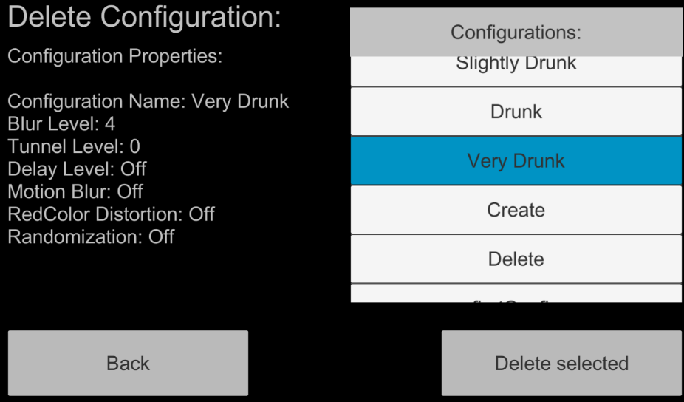

Abbildung 25: Delete Scene Preview

**Problems:**

This scene contains a scrollable list with all the configurations, both the default and custom configurations. From this list the user selects a configuration item and sees its values and deletes it if desired. If the selected item is a default configuration an error message is shown:

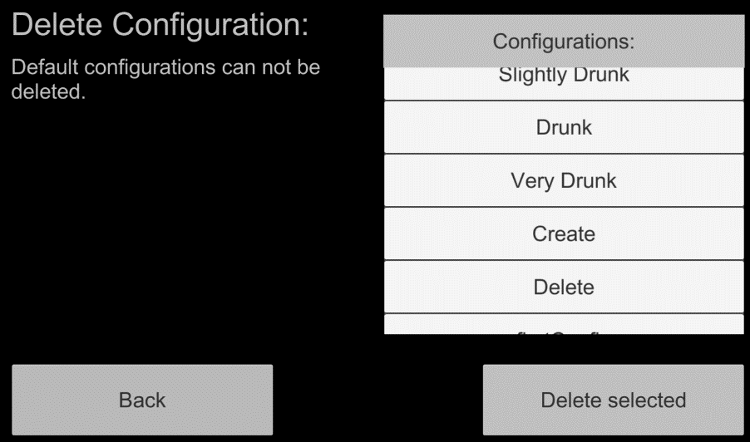

Abbildung 26: Delete Scene with Error Message

The problem is that Unity does not have standard GUI Elements like scrollable lists with selectable items. They have to be built from the given elements (Buttons, Fields, Panels, etc.) and filled dynamically at run time.

**Solutions:**

After doing some more research, we found several tutorials, which address this problem with the Unity tutorial[4] being the most appropriate for our needs.

This tutorial makes a scrollable list with buttons as list items starting from a panel with following features:

* The scrollable panel automatically scales to fit the content
* The content (buttons in this case) have their preferred sizes
* The content is clipped/masked using an image mask
* Vertical Scroll

The object’s hierarchy tree eventually looks like:

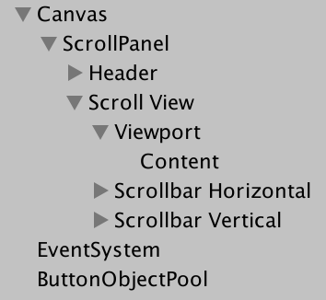

Abbildung 27: Scrollable List Hierarchy

Here’s what each object does and the components it needs:

**Canvas[5]**

The Canvas is the area that all UI elements should be inside. The Canvas is a Game Object with a Canvas component on it, and all UI elements must be children of such a Canvas.

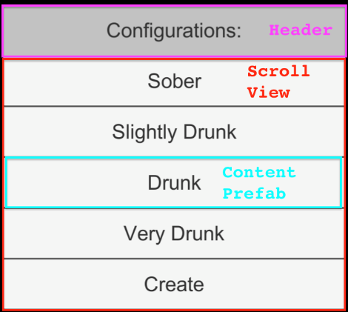**Scroll Panel**

Abbildung 28: Scrollable List Preview with Comments

This is just the parent Game Object containing the other elements

**Header**

A button without functionality

**Scroll View**

Contains elements that set up how the content is viewed. The **Viewport** is the component that actually contains the list elements. Both **Horizontal** and **Vertical scrollbars** define the list’s behavior when the user scrolls up or down the list. In this case, only vertical scrolling is allowed of course.

**Viewport Content: Button Prefabs**

The list will be filled on runtime with default configuration and custom configurations. That means that the length and size of the list is unknown until the scene is loaded and that we have to generate the list items and add them to the list dynamically.

For this we use Unity prefabs[6], a game object template from which you can create new object instances in the scene.

We built a button prefab with our desired features, and we instantiate them like:

public GameObject listButton; *// Button Prefab*

[…]

private void FillListInGui()  
{  
 foreach (var file in configFilesList)  
  {  
    var newButton = Instantiate(listButton); *// Instantiates Button Prefab*  
    var button = newButton.GetComponent<ListButton>();*// Button contains a C# class*  
    button.nameLabel.text = file.FileName; *// New button shows the file name*   
    var index = configFilesList.IndexOf(file);  
    button.button.onClick.AddListener(() => { OnButtonClicked(index); });  
    newButton.transform.SetParent(contentPanel); *// Adds new Button to parent panel in*

*// order to keep the hierarchy tree*  
     }  
}

The advantages of prefabs are obvious. You are able to reuse the prefab in different scenes in combination with different game objects and settings.

For more detailed information about the scrollable list with selectable items please refer to the above-mentioned Unity tutorial.

### Main Scene

The main scene is the entry point to the Simulating Substances application. From this scene, the user can create or delete configurations, start from a default configuration or start from a custom configuration.



Abbildung 29: Main Scene Preview

**Problems:**

Just like in the delete scene, the first problem was to implement a scrollable list with selectable items again. Please refer to the solutions in the delete scene section to see how that has been solved.

Another unexpected problem in this scene we discovered is that the application’s event processing does not work properly when the application is running on a mobile phone. When the user tries to select a list item by clicking on it, sometimes the first click gets lost and the selection does not work as intended. This behavior is not deterministic, so sometimes it works and other times it does not.

A rather long research revealed no documentation about this issue and the only preliminary conclusion we could come to is, that it is a still not documented bug in Unity or our test devices simply malfunction.

### Navigation between scenes

As our application has a simple structure with only 4 scenes we looked for a simple navigation solution too.

Unity offers the SceneManager[7], which manages the scenes at run-time and provides the following method:

        private void LoadScene(int sceneIndex)  
        {  
            SceneManager.LoadScene(sceneIndex);  
        }

Each scene has an index in the Unity Editor:

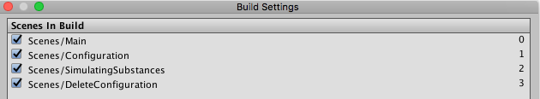

Abbildung 30: Unity Build Settings with Scene Index

So, whenever we need to navigate to another scene, we call the LoadScene method from a GUI component (e.g. a button) with the corresponding index:

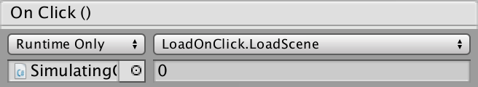

Abbildung 31: Button Click Event linked to Load Scene

# Challenges/Conclusion

## Differentiation between errors, bugs and limitations

One of the biggest challenges coming with the experimental focus of this project was the differentiation between encountering bugs and limitations. Due to our lack of previous experience with the used technologies, we were typically amazed how fast we could get something to run. But when that was not the case or the working feature had a small issue/bug, we basically always had to spend an exceptional amount of time on understanding why it was caused and attempting to fix it.

## Performance Optimization [13]

Even at the beginning of the development process while still experimenting with the different image effects, the smartphones used for testing seemed to reach their limit regarding performance/processing power. Since we were unaware of whether that is caused by our code or simply to be expected using the AR components at our hands, we ordered and read a book specifically written for this called “Unity 5 Game Optimization”.

The only techniques useful for our custom code within the Virtual Buzz app and elaborated in this book are roughly explained in the next small chapters. Due to the simplicity of the apps code, there sadly has not been a big performance achievement caused by those changes, but it sure helped with the overall understanding of Unity.

### Caching Component references

All elements in Unity are commonly accessed through the GameObject.Find (“COMPONENTNAME”).GetComponent<T>(); command and this is said to be a very costly call especially if it is done over and over again. So, in order to save performance here this sort of call should never be used in very frequently occurring calls and instead be done once in the initialization and then cached by reference.

### Removing empty callbacks

Upon creating new scripts which are derived from MonoBehaviour, there are two method templates added by default:

// Use this for initialization

void Start () {

}

// Update is called once per frame

void Update () {

}

Even if these declarations stay empty, they will be added to all the other methods of this type upon initialization and therefore do have a performance impact.

## Hardware limitations

As already indicated by the previous chapter, we have managed to identify quite a bit of hardware limitations when it comes to smartphones based AR experiences. In order to proof, that the developed app is expected to be more enjoyable on newer smartphones (optimized für AR/VR in the best caes), we have gathered the profiling data of three devices. All of the devices are using the same configuration in the hopes of comparing apples to apples.

Nexus 5X

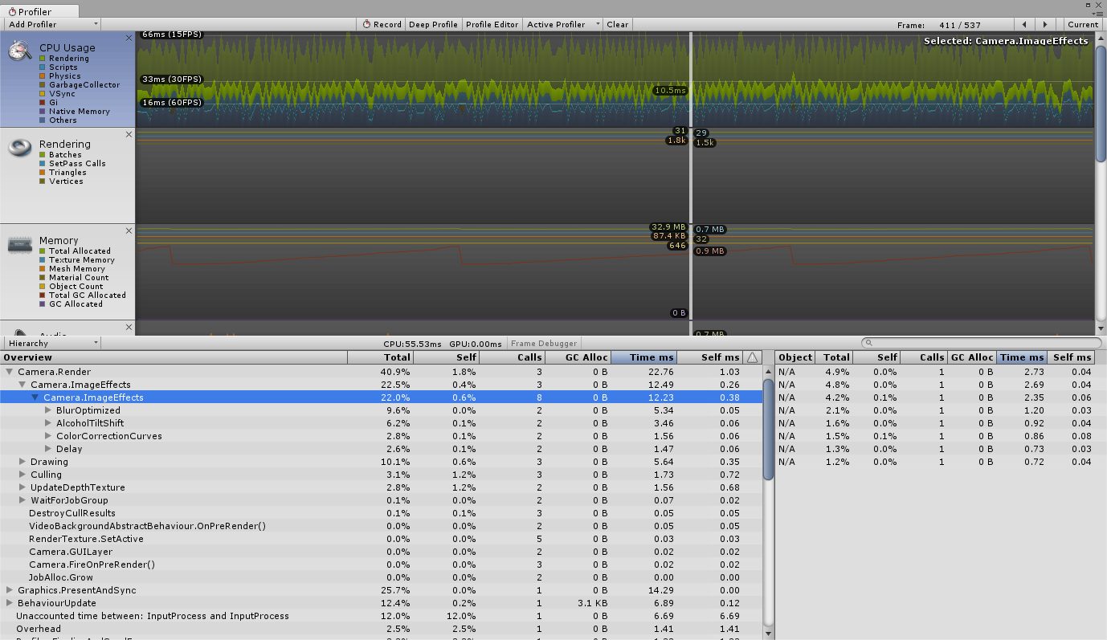

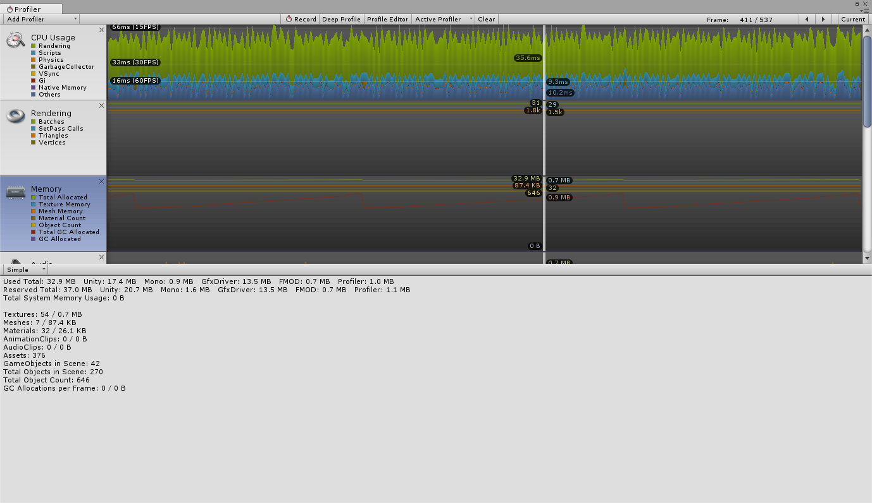

iPhone 6 Plus

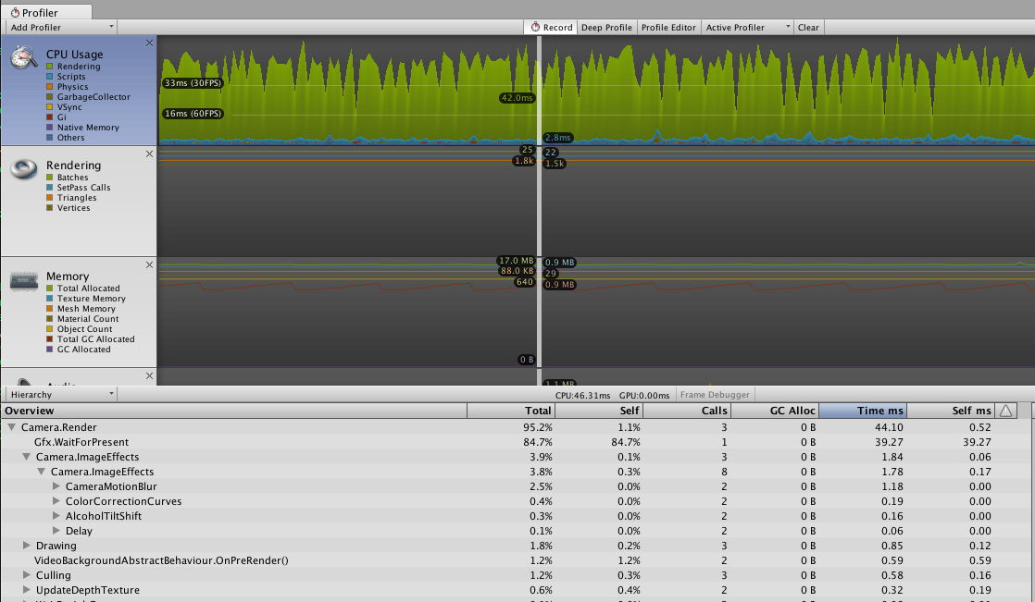

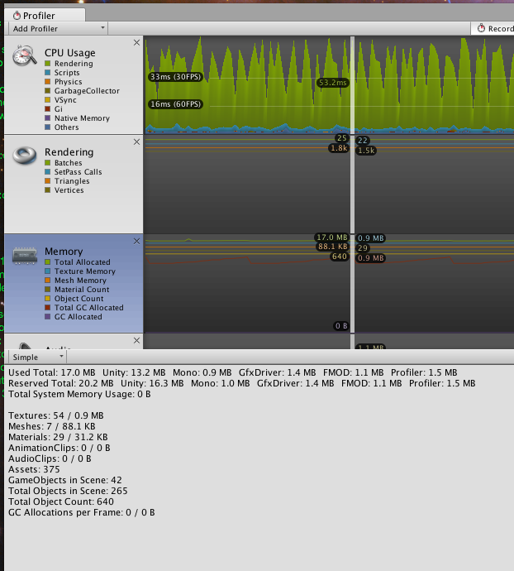

Home PC (CPU: Intel Core i7 980, 6 cores @ 3.33 GHz; GPU: ZOTAC GeForce GTX 1080, 2560 Cores @ 1911 MHz, 8 GB GDDR5X) using a 720p WebCam

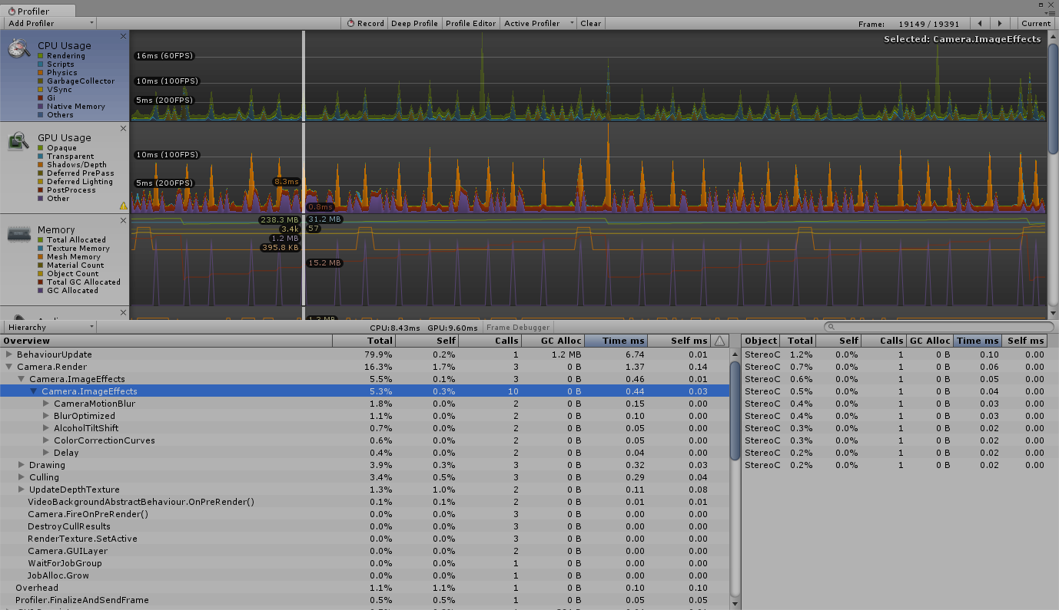

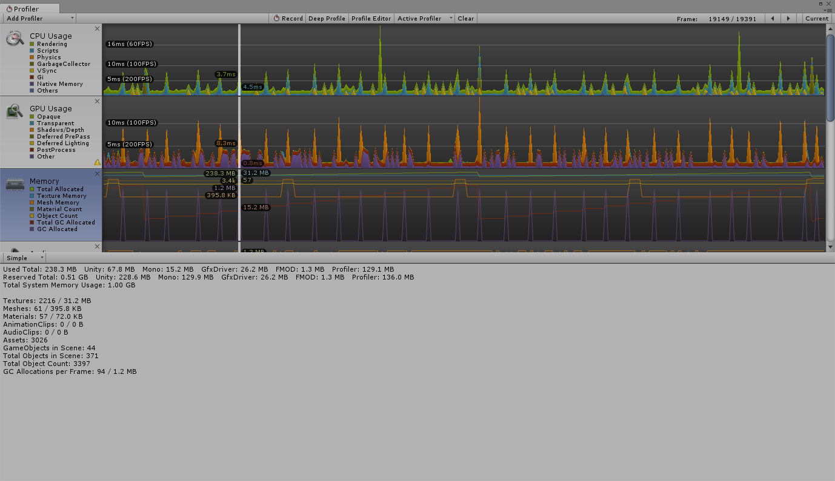

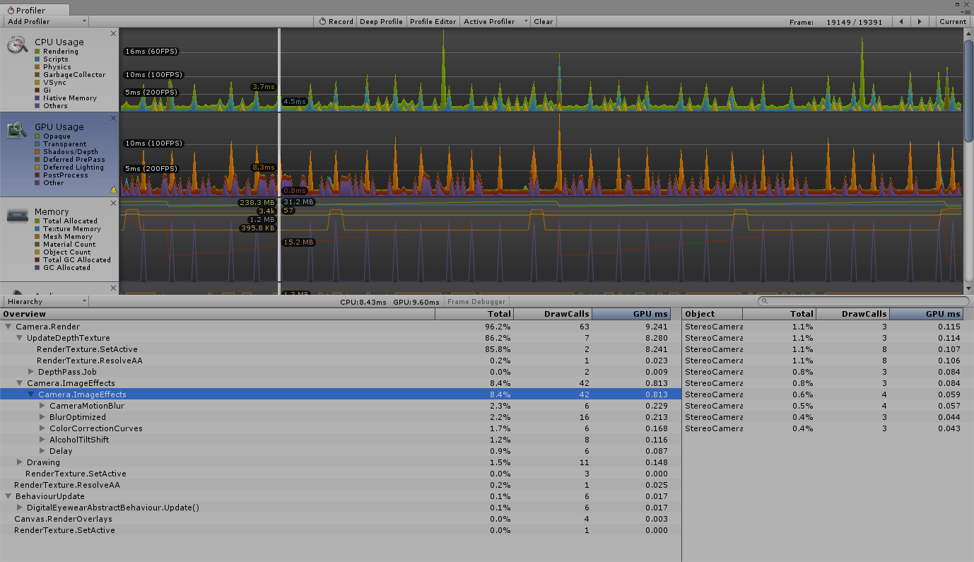

Nexus 5X observations:

10 min -> 5% battery consumption, noticeable heat around camera

15 min -> 8% battery consumption, very noticeable heat around camera

20 min -> 10% battery consumption, very noticeable heat across the upper parts of the phone

25 min -> 16% battery consumption, concerning heat across the upper parts of the phone

# Game Ideas

# Table of Figures

**No table of figures entries found.**

# Images

Abbildung 1: top 1000 free mobile games by engine [2] 12

Abbildung 2: Distribution of Scripts created by language [4] 13

Abbildung 3: Mathematical Visualization of the used Random Walk 18

# References

|  |  |
| --- | --- |
| [1] | 11 10 2016. [Online]. Available: http://www.businesswire.com/news/home/20161101006531/en/PTC-Unity-Announce-Strategic-Collaboration-Accelerate-Augmented. |
| [2] | Unity Technologies, 2016. [Online]. Available: https://unity3d.com/profiles/unity3d/themes/unity/images/company/pr/unity-vision-mobile-graph.jpg. |
| [3] | Unity Technologies, 2016. [Online]. Available: https://madewith.unity.com/. |
| [4] | 12 9 2014. [Online]. Available: https://blogs.unity3d.com/2014/09/03/documentation-unity-scripting-languages-and-you/. |
| [5] | Unity Technologies, «Unity Manual: Blur (optimized),» [Online]. Available: https://docs.unity3d.com/Manual/script-BlurOptimized.html. |
| [6] | R. Fisher, S. Perkins, A. Walker und E. Wolfart, «Image Processing Learning Resources: Gaussian Smoothing,» [Online]. Available: http://homepages.inf.ed.ac.uk/rbf/HIPR2/gsmooth.htm. [Zugriff am 25 12 2016]. |
| [7] | Unity Technologies, «Unity Manual: Motion Blur,» [Online]. Available: https://docs.unity3d.com/Manual/script-MotionBlur.html. [Zugriff am 25 12 2016]. |
| [8] | Unity Technologies, «Unity Manual: Camera Motion Blur,» [Online]. Available: https://docs.unity3d.com/Manual/script-CameraMotionBlur.html. [Zugriff am 25 12 2016]. |
| [9] | «UAH Math Resources: The Simple Random Walk,» [Online]. Available: http://www.math.uah.edu/stat/bernoulli/Walk.html. [Zugriff am 23 12 2016]. |
| [10] | «UAH Math Resources: Standard Brownian Motion,» [Online]. Available: http://www.math.uah.edu/stat/brown/Standard.html. [Zugriff am 23 12 2016]. |
| [11] | Qualcomm Vuforia, 14 12 2016. [Online]. Available: https://www.vuforia.com/-/media/Vuforia/Homepage/Singles/Vuforia%20Logo%20OLx2.png. |
| [12] | P. Milgram und T. Haruo, 1994. [Online]. Available: http://etclab.mie.utoronto.ca/publication/1994/Milgram_Takemura_SPIE1994.pdf. |
| [13] | [Online]. Available: http://www.fachstelle-asn.ch/images/asn-logo-de.png. |
| [14] | G. Abramovich, «CMO: ADI Gaming Report,» 16 9 2016. [Online]. Available: http://www.cmo.com/adobe-digital-insights/articles/2016/8/11/adi-us-gaming-report.html#gs.BvbHzyU. |

1. https://docs.unity3d.com/Manual/script-ColorCorrectionCurves.html
2. <https://github.com/HSR-Semester-Arbeit2016>
3. <https://hsr-semester-arbeit2016.github.io/>
4. https://unity3d.com/learn/tutorials/topics/user-interface-ui/intro-and-setup?playlist=17111
5. https://docs.unity3d.com/Manual/UICanvas.html
6. https://docs.unity3d.com/Manual/Prefabs.html
7. https://docs.unity3d.com/ScriptReference/SceneManagement.SceneManager.html